Project Design Phase
Solution Architecture

Date | 03 December 2025
Team ID
Project Name | Flight Booking System
Maximum Marks | 4 Marks

Solution Architecture:
The solution architecture of the Flight Booking System is designed to provide a secure, scalable, and user-friendly platform for seamless air ticket booking. It emphasizes fast flight search, real-time updates from airline data, smooth and secure payment processing, and reliable ticket/PNR generation. This setup ensures a smooth experience for passengers and efficient management capabilities for administrators.
Key Architectural Capabilities:
- Seamless end-to-end flight search and booking journey.
- Complete ticket lifecycle: search → view details → pay → receive ticket/PNR.
- Scalable authentication and access control for both passengers and admin users.
- Secure online payment handling with instant ticket and PNR generation.
- Real-time synchronization of flight availability and pricing.
- Reliable SMS/Email notifications for booking confirmations and updates.
- Centralized control over flights, schedules, and booking records.

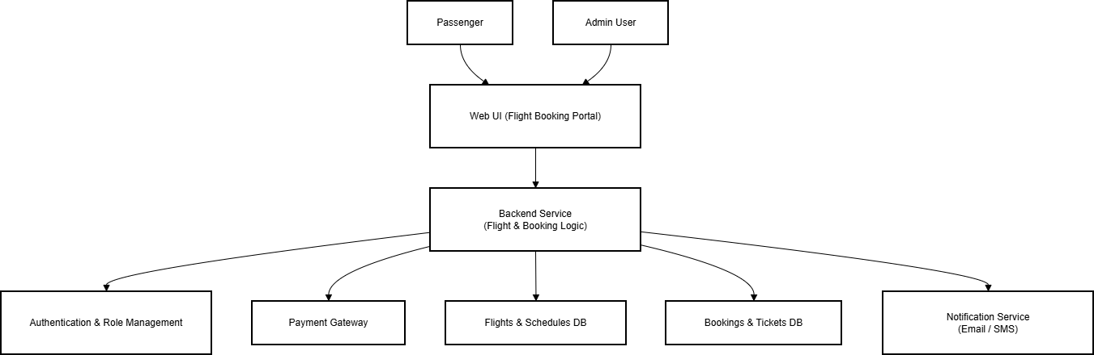
Example - Solution Architecture Diagram:

